7. Sonometer

**7.1AIM**

1. To measure and analyze the resonance modes of a stretched string using Sonometer apparatus.

2. To measure the velocity of propagation of wave through a stretched string.

**7.2 PRINCIPLE**

When a stretched string is excited by a sinusoidal force, for certain frequencies its amplitude is maximum. This is referred to as resonance and occurs when the following condition is satisfied -

$$λ=\frac{V}{ν}= \frac{2L}{n}$$

Where

n is a integer and can take positive values

L – length of the stretched string

λ - wavelength

V – velocity of the wave.

ν - frequency of sound wave

**For different frequencies, the fundamental (n=1) resonance length is found out. Standing waves are formed on the stretched string.**

**7.3 EQUIPMENTS REQUIRED**

Table I : Equipment and the items required for performing the experiment.

|  |  |  |
| --- | --- | --- |
| **S. No.** | **Required item** | **Utility** |
| 1 | String | To propagate wave |
| 2 | String adjustment knob | To adjust the string length |
| 3 | Tuning forks | To excite the strings |
| 4 | Detector coil | To detect vibrations in string |
| 5 | Tensioning lever | To hang weight at different points which makes changes in tension |
| 6 | Oscilloscope | To display output of detector coil |
| 7 | Weights | To generate tension |
| 8 | Weight hanger | To hold the weights |

**7.4 PROCEDURE**

Two physical quantities need to be measured in this experiment – mass and length.

Make the following table –

Table II : The details of the physical quantities to be measured.

|  |  |  |  |  |  |  |
| --- | --- | --- | --- | --- | --- | --- |
| S.No | Physical quantity | Independent /  Dependent | Measured  with | Measuring instrument’s | | |
| Minimum | Maximum | Least count |
| 1 | Length | dependent | Meter scale |  |  |  |
| 2 | Mass | independent | Weighting machine |  |  |  |

Set up the Sonometer as shown in Figure below:

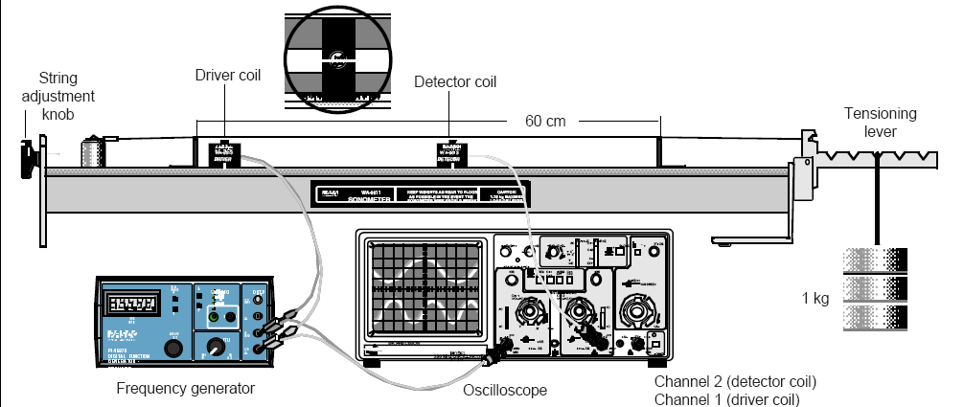

**Resonance modes:**

1. Set the Sonometer parallel to table edge.
2. Insert two bridges under the string about 60 cm apart. Also place a small piece of paper on the string.
3. Hang a mass of 1 kg from the tensioning lever. Adjust the string adjustment knob so that the tensioning lever is horizontal.

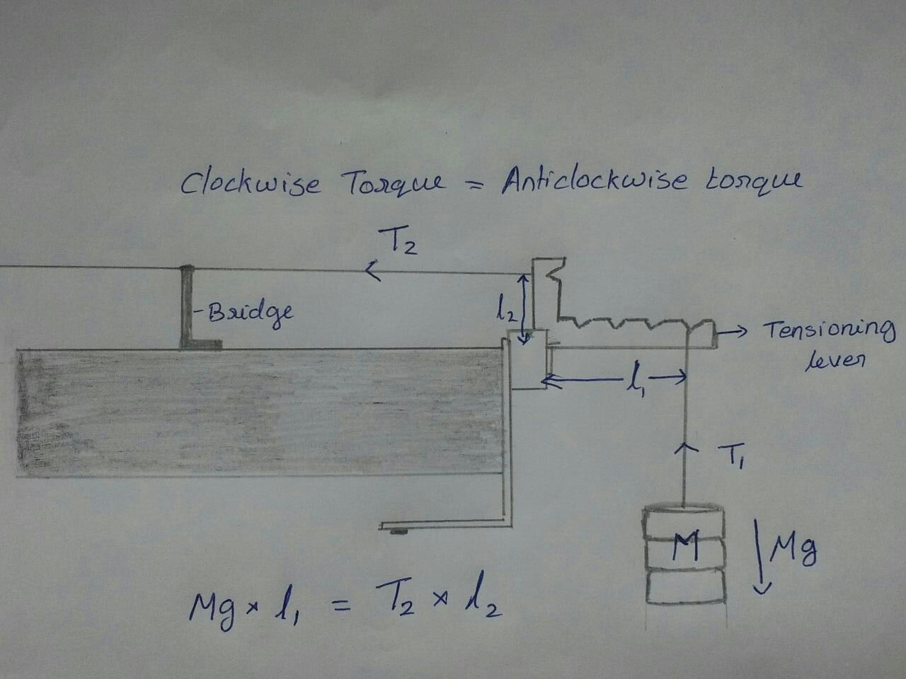

1. Measure the total length, and mass of the string. These values are used for the calculation of mass/length of the string.
2. Take a tuning fork of the highest frequency from the box.
3. Hit it on the rubber hammer and place it on the sonometer. Observe if the rider falls off. If the rider does not fall off, change the position of one of the bridges and check. Repeat this until the rider falls off.

**Rider falling off indicates that the amplitude of the wave on the string is maximum and hence this is resonance length.**

1. Now, insert the detector coil at the center of the bridges under the coil and observe the oscilloscope signal.
2. The oscilloscope settings should be as follows –
   1. Volts/div – 2mV
   2. Time/div – 2 mS
3. Make finer adjustments to the bridge position to obtain a sine curve with maximum amplitude. Note down the distance between the bridges as resonance length.
4. To check if this is the fundamental mode, reduce the distance between the bridges to half and check for resonance.
5. Find the fundamental resonance length for each of the tuning forks available.

|  |  |  |  |
| --- | --- | --- | --- |
|  | Tuning fork frequency (Hz) | Fundamental length (cm) | Wavelength (cm) |
| 1 |  |  |  |
| 2 |  |  |  |
| 3 |  |  |  |
| 4 |  |  |  |

Plot a graph υ vs 1/L. The slope of the line is related to the speed of the wave.

**How to measure Tension:**

Clockwise torque = Anticlockwise torque

Tension * perpendicular length = mg * length of tension in the string

* 1. **STUDY QUESTIONS**

1. Can we use n=2 and perform the experiment ?
2. Why do we see a sine wave on the ossciloscope ?
3. Explain the working of tension lever.
4. What type of waves is produced by a stretched string under vibration?
5. What happens to the frequency of the wire when the resonating length of the wire increases?
6. Which type of material is used for a sonometer wire?
7. What are the factors on which the frequency of stretched string depends upon?
8. What is the relation between mass of the slotted weight and resonating length of the string?
9. Can you use a rubber wire in sonometer experiment instead of a metal wire?
   1. **FURTHER SCOPE OF EXPERIMENTS**
10. Perform the experiment to see the effect of the tension in the string.
11. Perforn the experiment with a different string.
12. Can we use sonometer experiment to calculate unknown frequency?
    1. **PRECAUTIONS**
13. Use only the horizontal position of the tension lever.
14. Confirm the fundamental mode by changing the length to half.
15. Ensure that the sonometer wire is of uniform cross section and free of kinks.
16. Adjust the voltage so that none of the equipments get damaged.
17. Adjust the string horizontally without slope.
18. Mass should not be more than 5 kg
19. Keep detector exactly between two bridges
    1. **SOURCES OF ERROR**
20. Determination of correct position where the maximum displacement occurs.
21. String not in a taut position.
    1. **THEORY**

Standing Waves: A simple sine wave traveling along a taut string can be described by the equation,

y1 = sin (x -)

The reflected wave can be described by the equation,

y2 = sin (x )

Resultant standing wave can be described by,

$y=2y_{m}\sin\left(\frac{2π}{λ}x\right)cos⁡(\frac{2π}{λ}vt)$

Resonance: At certain frequencies of oscillation, all the reflected waves are in phase, resulting in a very high amplitude standing wave. These frequencies are called resonant frequencies. In general, resonance occurs when the wavelength satisfies the condition:

 = 2L /n; n = 1, 2, 3, 4…

Velocity of Wave Propagation: The velocity of wave propagation (V) on a stretched string depends on two variables: the mass per unit length or linear density of the string ($μ$) and the tension of the string (T). The relationship is given by the equation:



The tension is varied using hanging weights on a lever arm. The wavelength is then measured by adjusting the frequency until a resonance pattern develops. The velocity can then be calculated using the relationship V =  and the effects of tension and linear density on velocity can be determined.

**2.11 FURTHER READING AND RESOURCES**

**Text books**

Book - Gardner, Robert, 1990. *Famous Experiments You Can Do.* New York, NY: Franklin Watts (pp. 103–104).

**Internet**

Internet -Blauch, D., 2004. "Gas Laws: Pressure", Department of Chemistry, Davidson College [accessed January 23, 2006]  <http://www.chm.davidson.edu/ChemistryApplets/GasLaws/Pressure.html>

**Java apps/apps**

University of Colorado, B. (n.d.). *Masses & Springs*. Retrieved from PhET Interactive Simulations: [**https://phet.colorado.edu/en/simulation/mass-spring-labA**](https://phet.colorado.edu/en/simulation/mass-spring-labA)

**Videos**

1. Andersen, P. (2014, August). *Simple Harmonic Motion, Bozeman Science*. Retrieved from YouTube: <https://www.youtube.com/watch?v=tudxily5Qu0>
2. Lewin, W. H. (1999). MIT 8.01 Physics I: Classical Mechanics, Fall 1999. *Lecture 10: Hooke's Law - Springs - Simple Harmonic Motion - Pendulum - Small Angle Approximation*. Retrieved from Internet Archive:<https://ia601409.us.archive.org/6/items/MIT8.01F99/10.mp4>

**Internet**

* **Lab 4 physics**
* **Physics lab manual, exercises for physics Allahabad University**

**Videos**

**You tube**

1. **Sonometer:** [**https://youtu.be/GTnPEtksTEc**](https://youtu.be/GTnPEtksTEc)
2. **To determine frequency of AC mains using sonometer**

**https://youtu.be/F6SlpUOXkPo**

b